|  |  |  |  |  |
| --- | --- | --- | --- | --- |
| About Me Hello Travelopia, My name Is Jatin Sharma, a front-end developer, always trying to focusing on better User interface and better page performance using HTML5, CSS3 and Javascript.   * This is the documentation for the problem : A page has a problem with the conversion rate is not as high as it could be. * The Web Owner thinks that if the description content is shortened, the Users are more likely to see the * Call To Action sections and thus more likely to book a Tour with us. * Your job is to produce javascript and css to update the description on the page. * This documentation includes everything from scratch how I have solved this problem |  |  | |  | | --- | | Task-Documentation  Phone: +91 7284873072  Email: [mca22.jatin.sharma@sunstone.edu.in](mailto:mca22.jatin.sharma@sunstone.edu.in)  Web: https://travelopia-task-by-jatin.netlify.app | |
| Contact Us For any query, you can contact me anytime.  Phone: +91 7284873072  Email: mca22.jatin.sharma@sunstone.edu.in  Portfolio : https://jatiin.netlify.app/ |

|  |  |  |  |  |
| --- | --- | --- | --- | --- |
| Table of Contents  **Problem** **1**  **Solution** **2**  **Proof/Screenshot** **2** |  |  |  | |
|  |  |  | What is the problem ? Explaining the main problem breifly |
|  | What is the Solution Explaining the approach in brief along with some code |
|  | Proof or screenshots To show the code and the proof that how efficiently the problem has been solved. |
|  |  |  | 5 | |

|  |  |
| --- | --- |
| Problem Statement : There is a page has a certain problem and that is The conversion rate is not as high as it could be.  The Web Owner thinks that if the description content is shortened, the Users are more likely to see the  Call To Action sections and thus more likely to book a Tour with us.  Our task is to produce javascript and css to update the description on the page as shown below.  Current Page :   How it should look like : |  |
|  |
|
|
| -Plus we have to focus on the page performance and the SEO part for the page. |  | |  | 1 |

|  |  |  |  |
| --- | --- | --- | --- |
| SolutionWhat to Include? This project aims to increase the conversion rate of a specific page on the **Travelopia** website by shortening the length of the description content. This is intended to make the Call To Action sections more visible to users, potentially leading to an increase in tour bookings. Focus on What You Do Best **JavaScript**: A JavaScript function has been implemented to dynamically shorten the description content on the page.  **CSS**: CSS styles have been added to manage the visual appearance of the shortened description, ensuring a clean and user-friendly presentation.  Using HTML5 we will use the perfect tag for each element and structured our page in a well manner so that our page stands out |  |  |  |

HTML Meta, helping me in enhancing the SEO :

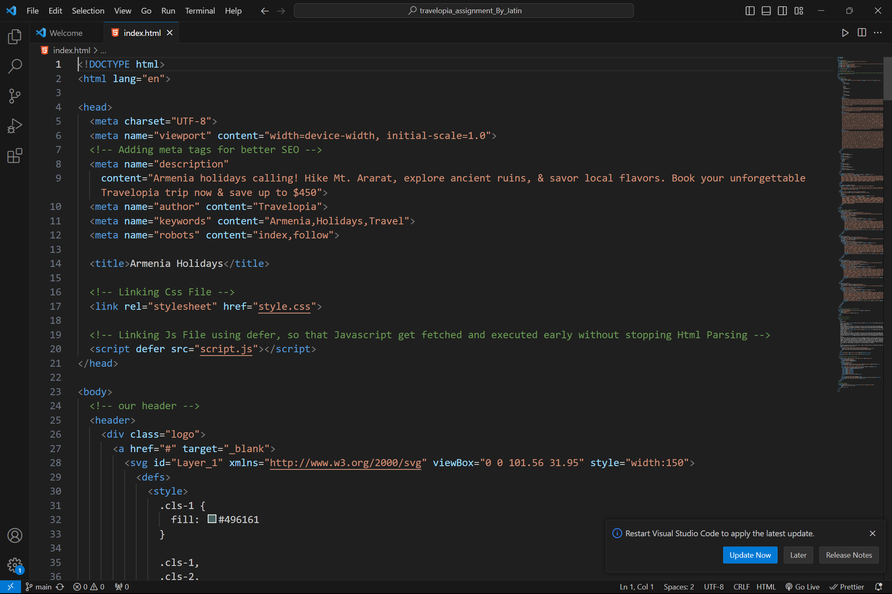

|  |  |  |  |
| --- | --- | --- | --- |
| Right HTML Tags helps the page in performance and accessibility |  |  | 3 |

Proof/ Screenshot :

Our page on Mobile-view:

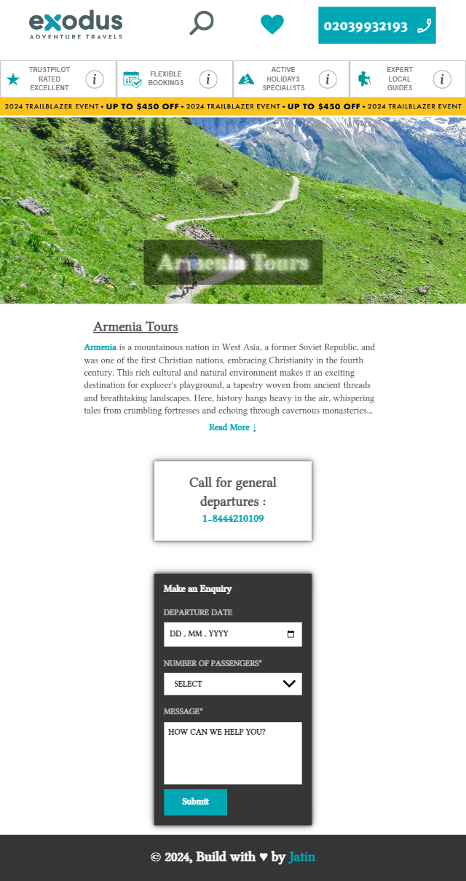

Our Page overall performance :

Page performance is calculated using Chrome Dev Tool called as “Lightroom”.

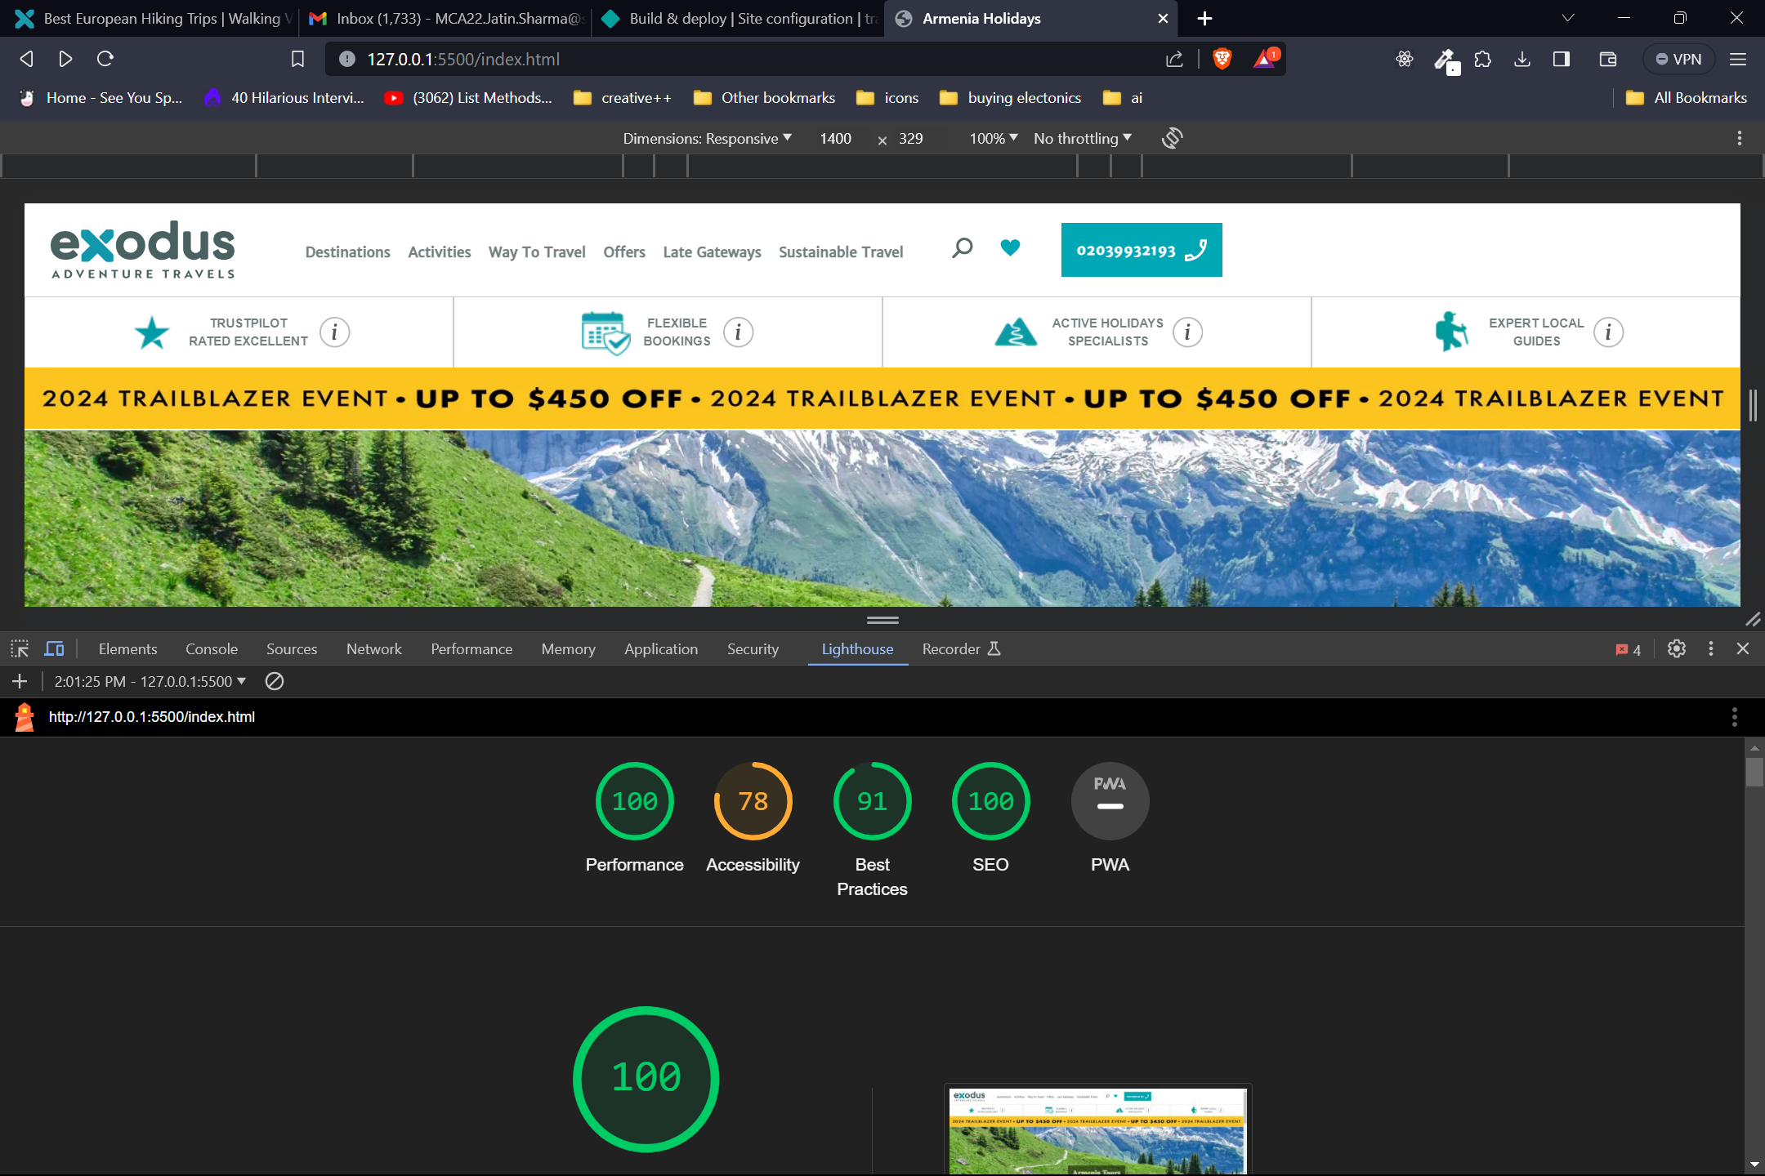

Thank you